myplace Participant Portal
Step by Step Guide
November 2016

Changes from the last version
The following updates have been made since the last published version of this guide:
- Service Bookings – added more descriptions and expanded the process steps explanations
- Bank Account Details – added information on editing these details

Table of Contents
Changes from the last version 2
Introduction 5
What can Participants do in myplace? 5
Disclaimer 5
Support 5
Sign in 6
Internet browser requirements 6
To sign into myplace for the first time: 6
Nominees 9
myplace homepage 10
myplace homepage components 11
myplace Navigation 12
Using a function 12
Returning to the myplace homepage at any time 12
For Help 12
My Contact Details 13
My Plan 15
View My Plan 15
My Helpful Documents 18
My Support Budget 19
My Referrals 20
My Service Bookings 21
Create a New Service Booking 21
View Existing Bookings 27
What if I am self-managing funding in my plan? 28
What if I have a Plan Management Provider? 28
How do I change my Service Bookings? 28
End Service Booking 29
Update Allocation 31
My Payment Request (previously called Claims) 33
Create a Payment Request (Claim) 33
View Payment Requests (Claims) 36
Cancel Payment Requests 38
My Appointments 41
My Messages 42
Events 43
Document Upload 44
Products and Services 45
myGov Inbox 46

Introduction
The myplace Participant Portal is a secure website for Participants to view their NDIS plan and manage their services with Providers.
This Step by Step Guide provides help and instructions on how to use the myplace Participant Portal.

What can Participants do in myplace?
You can use the myplace portal to:
- View and update your contact details
- View your NDIS Plan, information about your funded supports and your current budget
- Create and manage Service Bookings with Providers
- View messages from NDIS
- View any current referrals and appointments
- Instant message with your linked Providers
- Upload required documents
- Locate Service Providers
- View upcoming events
If you are Self Managing funded supports in your NDIS plan you will also use myplace to receive payments for supports purchased. You can do this by making a Payment Request (previously called a claim).

Disclaimer
This guide is intended for instructional purposes only. Person data shown in this guide is fictional.

Support
Please direct any queries to 1800 800 110.

Sign in
If you were using the NDIS Participant Portal before July 2016, you will access the new myplace portal using your existing sign in.
If you have not accessed the Portal previously, to sign in to myplace you will need:
- A myGov account. For instructions on how to create a myGov account refer to Creating a myGov account on the myGov help webpage. In MyGov you must link to the National Disability Insurance Scheme (this is done through the Services section).
- An Activation Code from the NDIS (this code is needed for the first logon only).
Once your NDIS Plan has been approved a letter confirming your Activation Code will be sent via your preferred method of correspondence. This code will expire after 10 days. You can contact the agency on 1800 800 110 to obtain a new Activation Code if required.

Internet browser requirements
To access myplace, please log in using one of the following:
- Internet Explorer
- Microsoft Edge (only on Windows 10)
- Chrome
- Firefox
- Safari

To sign into myplace for the first time:
- Select the myplace Participant Portal link on the NDIS website.
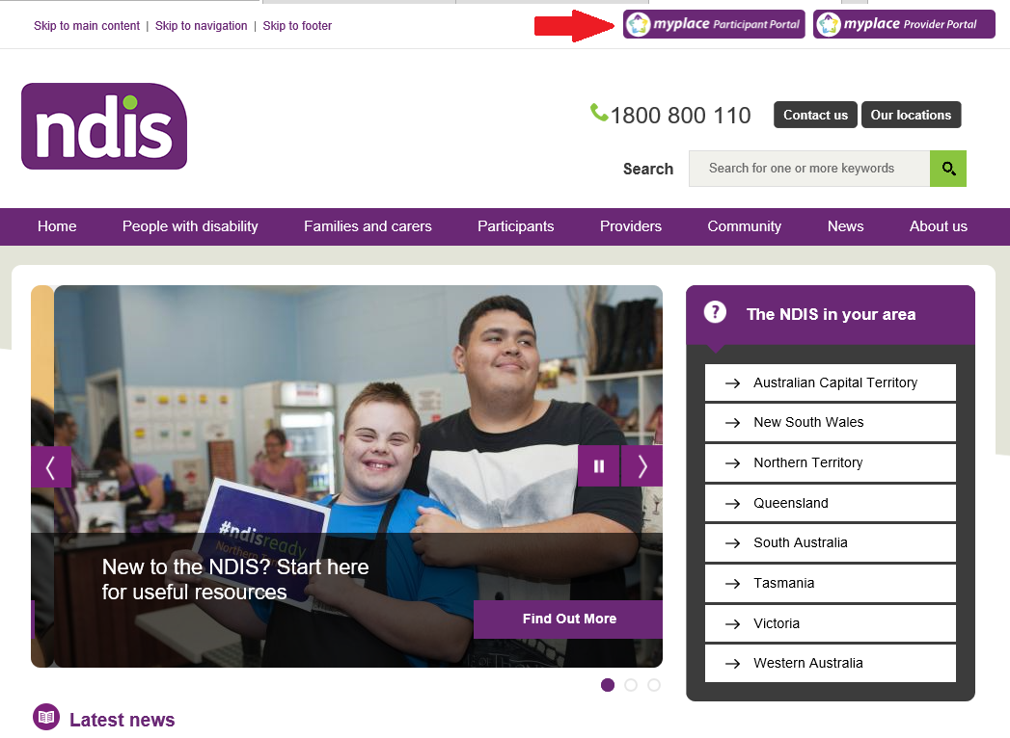
- Type in your myGov username and password and select Sign in.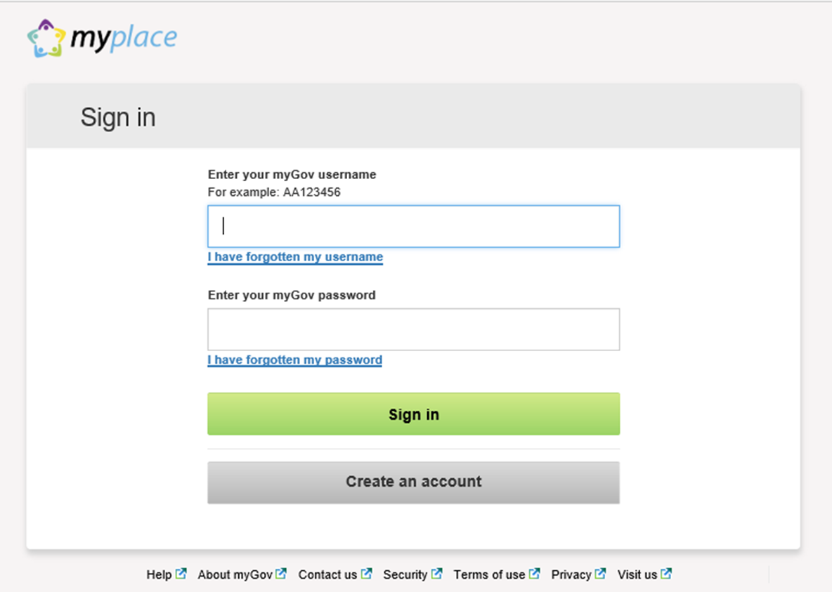
- Type in the single use security code that you received on your mobile (or answer the security question) and select Next.
Please note: if you are using the secret question, another screen displays.
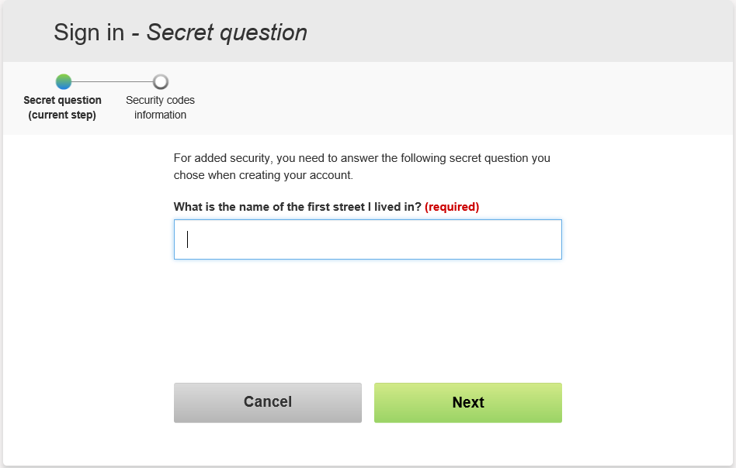
Please keep your security code and secret questions in a safe place.

- Type in your Activation Code, your Last Name, and Date of Birth, then select Submit.
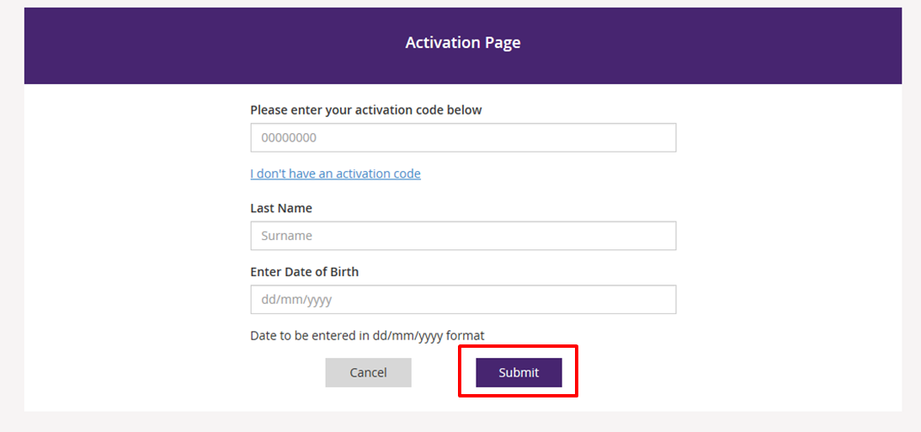
Please note: you only have to put in the NDIS activation code once. This screen will not display again.
- You need to accept the Terms of Use before you can use the myplace portal.
- Use the scrollbar to view the Terms of Use.
- If you accept the Terms of Use, select on the box located next to I have read and accepted the terms of use.
- Select Accept to continue logging in to myplace.
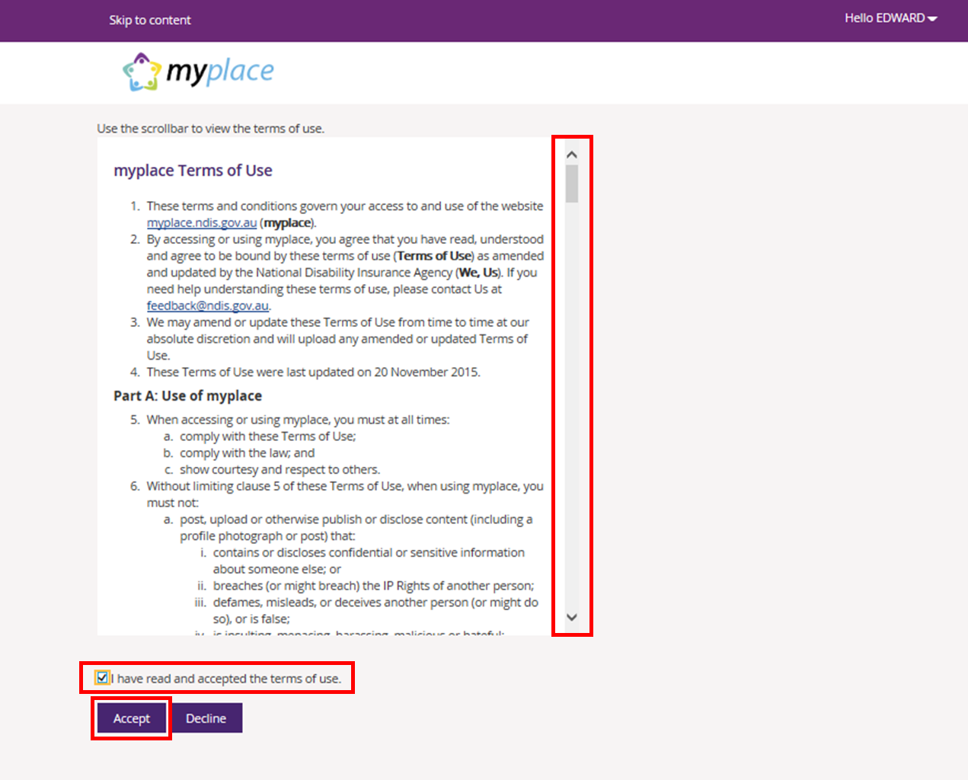

Please note: The Terms of Use will display on the first time you sign in to myplace, and when there have been updates to the myplace portal.

Nominees
A Nominee can be appointed where requested by a Participant, or as necessary. A Plan Nominee can undertake all activities that a Participant would using myplace. A Correspondence Nominee can use the portal to see information however cannot make changes to the plan or manage plan funds.
Generally, a child will be represented by the person or persons who have parental responsibility for the child. Similar to a Nominee, a Child Representative can undertake all activities in myplace on behalf of the Participant.
For further information, please refer to Operational Guidelines for Nominees on the NDIS website: https://www.ndis.gov.au/operational-guideline/nominees-sitemap.html

Both Nominees and Child Representatives must access myplace through their own MyGov account.
When accessing myplace as a Nominee or Child Representative, you need to make sure you select the name of the Participant from the drop down box in the top right hand corner of the screen.
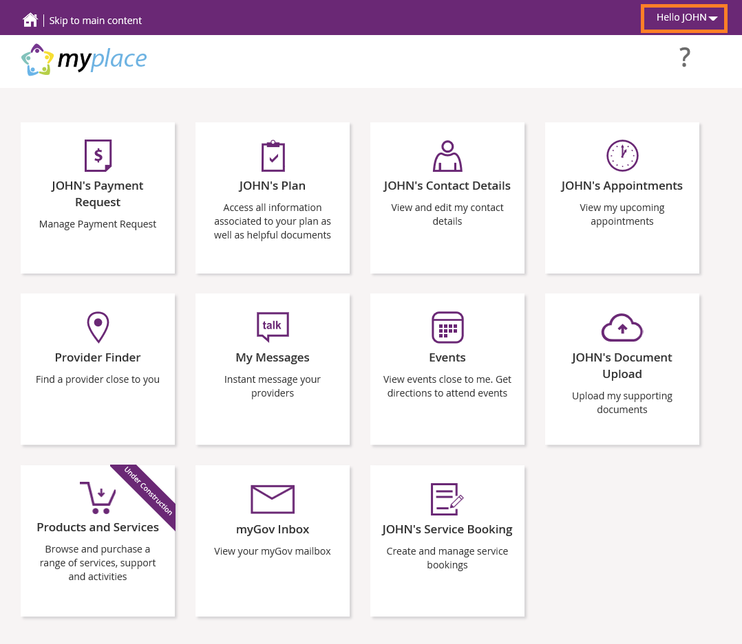

myplace homepage
The myplace homepage displays once you have signed in.
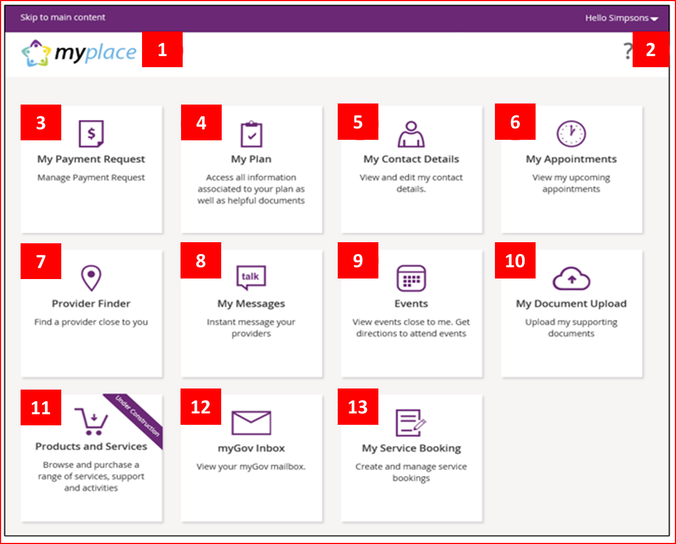

Refer to the following table for information on the myplace portal homepage components.

myplace homepage components
Reference | Homepage Section | Function
1 | myplace icon | Select this icon at any time to return to the myplace homepage.
2 | Help icon | Select this icon for simple explanations of the functions displayed on the screen.
3 | My Payment Request | Create, view and manage new and existing Payment Requests (previously called Claims)
4 | My Plan | View your current NDIS Plan here.
5 | My Contact Details | View and edit your contact details here.
6 | My Appointments | View upcoming scheduled appointments.
7 | Provider Finder | Find a Provider near you.
8 | My Messages | Instant messaging with your Providers.
9 | Events | View events based close to you.
10 | My Document Upload | Upload your supporting documents.
11 | Products and Services | This function is under development and will be available as further improvements are made to myplace. When available, this function will allow you to browse and purchase a range of services and supports.
12 | myGov Inbox | View your myGov Mailbox.
13 | My Service Bookings | Create and view all your Service Bookings.

myplace Navigation

Using a function
Select the function tile displayed in the myplace homepage to go into that section of the portal.
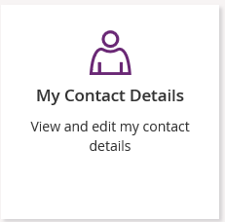

Returning to the myplace homepage at any time
There are two ways you can return to the myplace homepage.
- Select the myplace logo.
- Select the Home button to return to the myplace homepage.

For Help
Select the question mark icon for simple explanations of the functions on that page.
Select Contact Us at the bottom of the screen.

My Contact Details
Contact Details includes information about how the NDIS can contact you, your address, and relevant information about your relationships. View and ensure all your contact details are current here.
Bank account details can be also be checked or updated in the My Contact Details section of the portal by Self-Managed Participants and Child Representatives and Nominees who are Payment Nominees for a Self-Managed Participant. It is important that Payment Nominees update their own bank account details and not the Participants.
When you update your bank account details, the system sends you the following SMS if you have included a mobile number in your contact details: “Please note we have updated your bank account details as requested. If necessary, contact NDIA on 1800 800 110.”
- Select My Contact Details on the myplace home page.
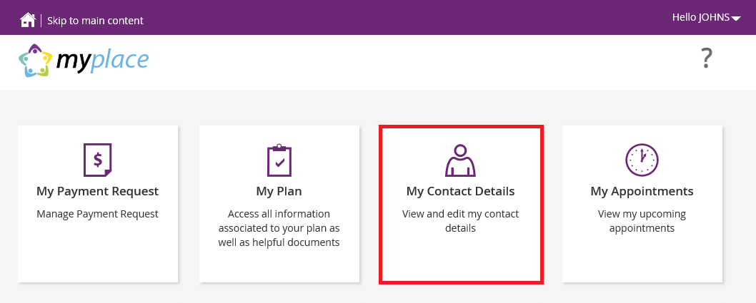
The My Contact Details screen displays.
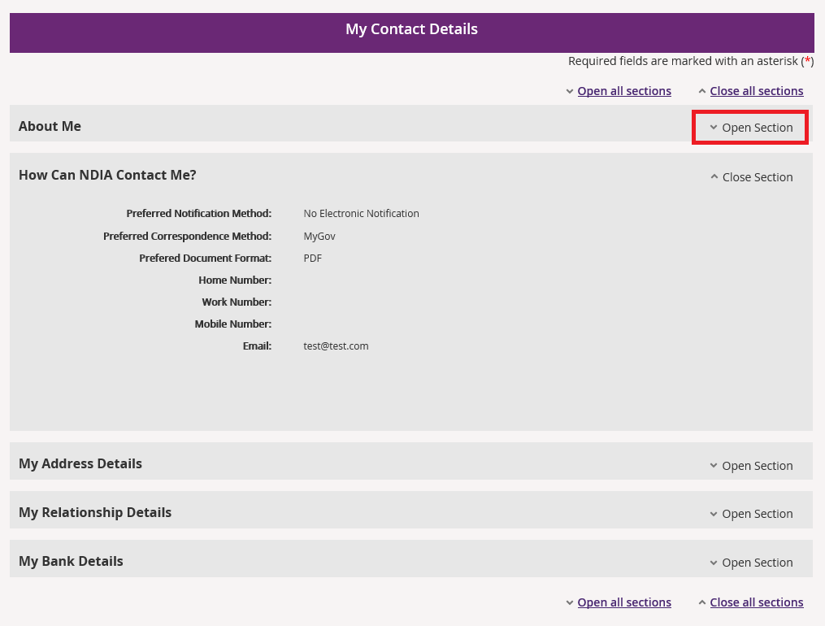
Select Open Section to display details under each heading.

- To amend any information select the Edit button in that section, if available.
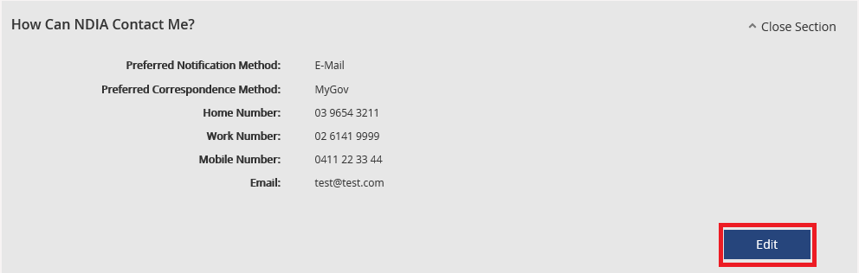
Please note: if you are adding a new address, the system will automatically put an end date to your existing address.

My Plan
You can use this function to view your most recent NDIS Plan, guideline documents, your support budget and referrals.

View My Plan
- Select My Plan on the myplace home page.
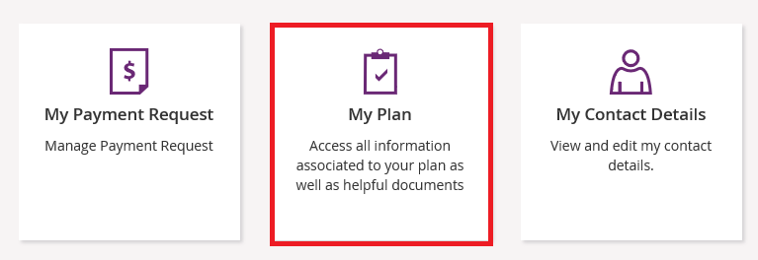
- Select View My Plan.
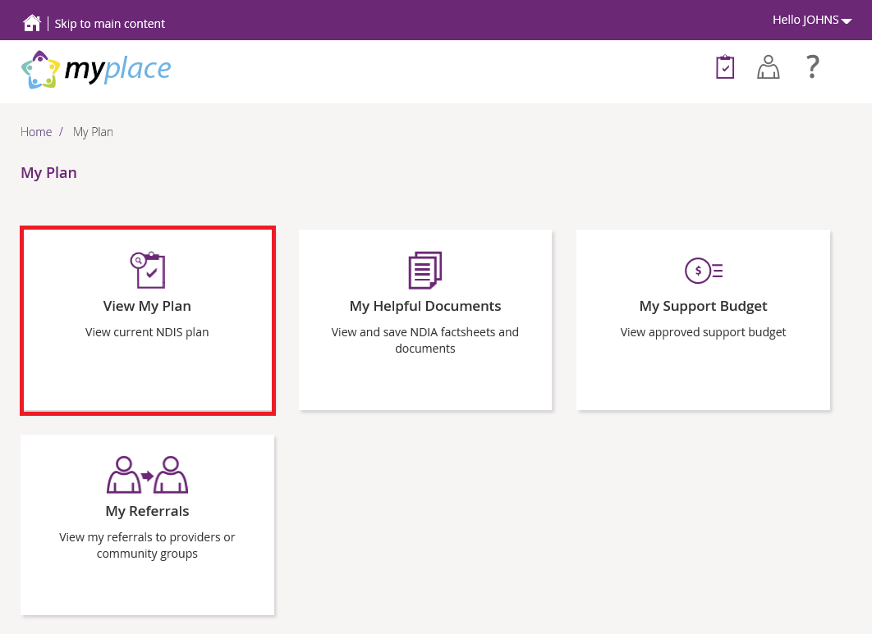
Your plan details display.

- Use the Open Section to view details under each of the headings.

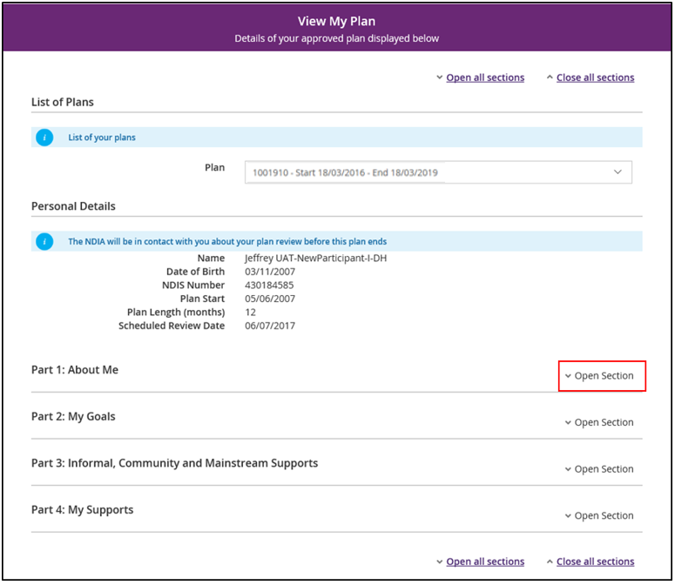

Part 4: My Supports lists all your funded supports against the support type or category.
Important note: quoted items will display as $0.00 on your plan until the quote is approved. Once the quote is approved, the amount will display on the plan.
- To print a copy of your plan, select the Print this Plan to PDF button in the top right hand corner of the screen.

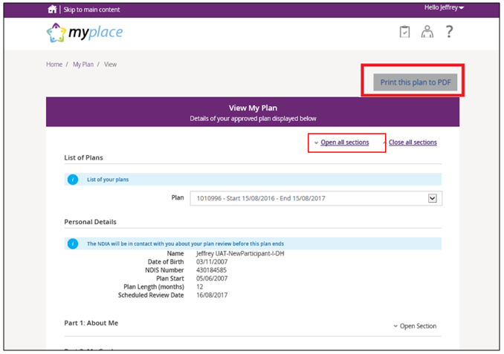

My Helpful Documents
You can use this function to access useful guideline documents for your Plan.
- Select My Helpful Documents on the My Plan page.
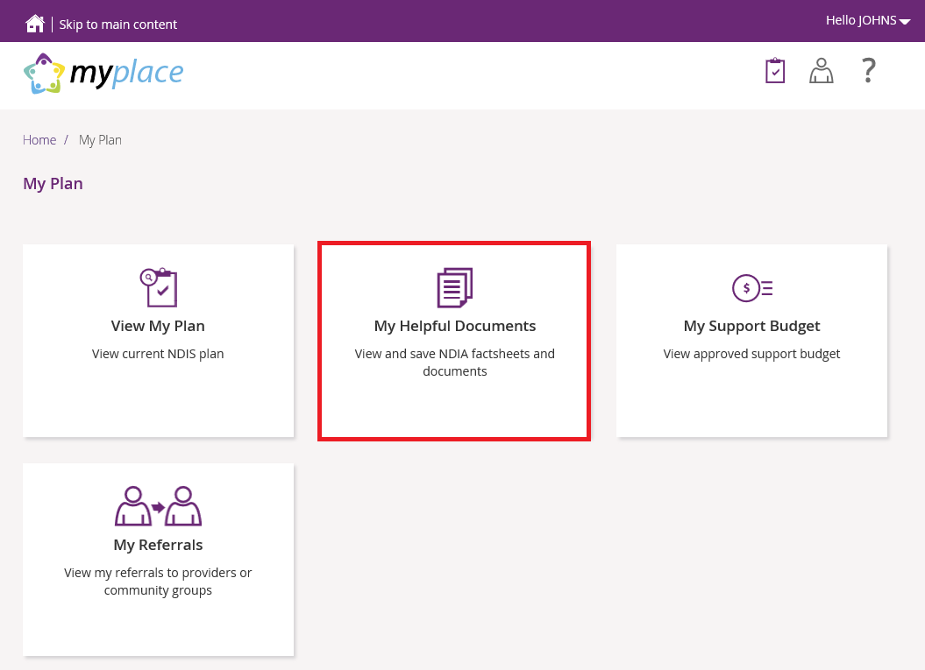

- The Helpful Documents page displays. You can access any document by clicking the document name link.
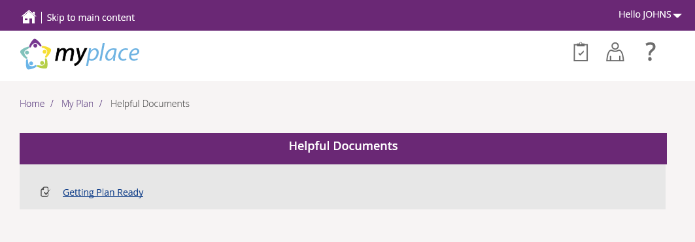

My Support Budget
You can use this function to view a summary of your funded support budget. This is based on information in your current NDIS Plan and will show your approved funds, funds spent, and funds remaining.
- Select My Support Budget on the My Plan page.
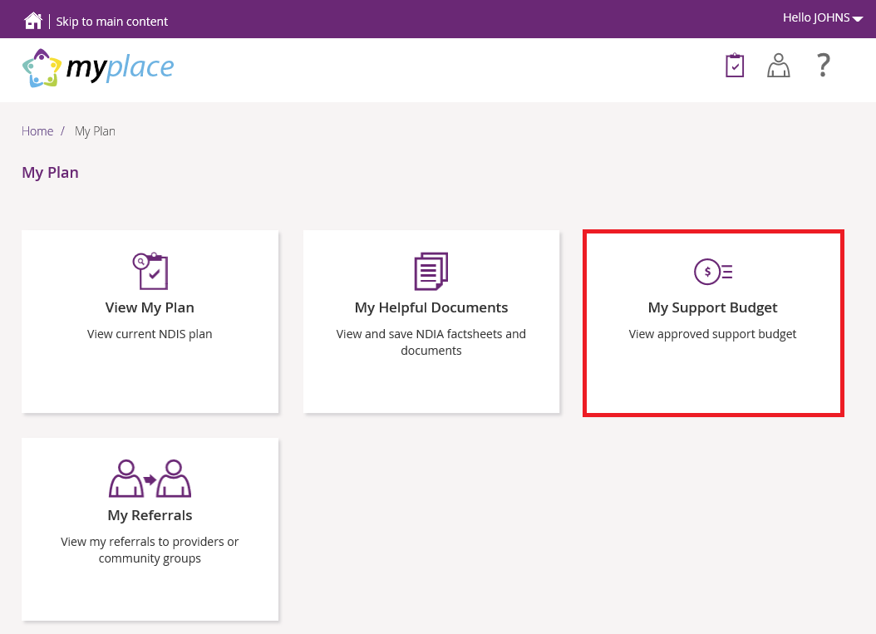
- A summary of your approved NDIS Plan support budget is displayed.
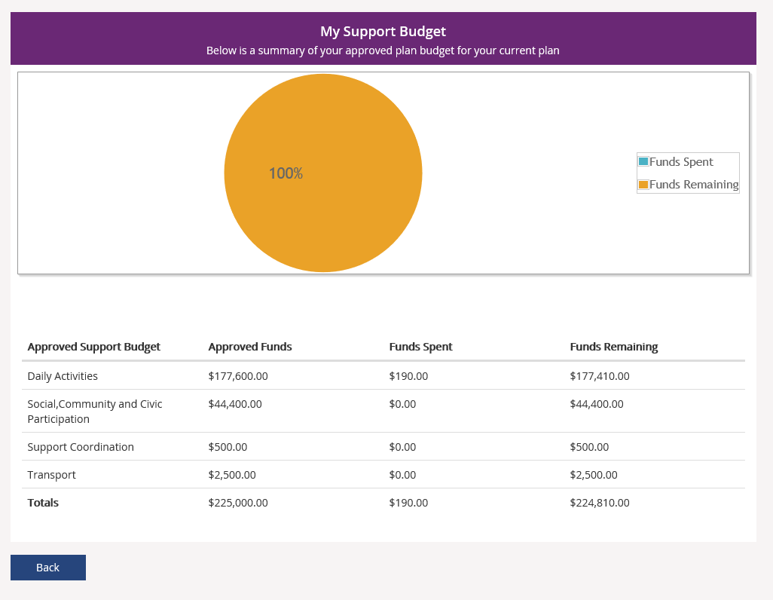
The table and pie chart only reflect payments which have been processed and paid. The figures do not include Payment Requests (previously called Claims) which have been submitted, but not yet processed.

My Referrals
You can use this function to view any current referrals you have.
- Select My Referrals on the My Plan page.
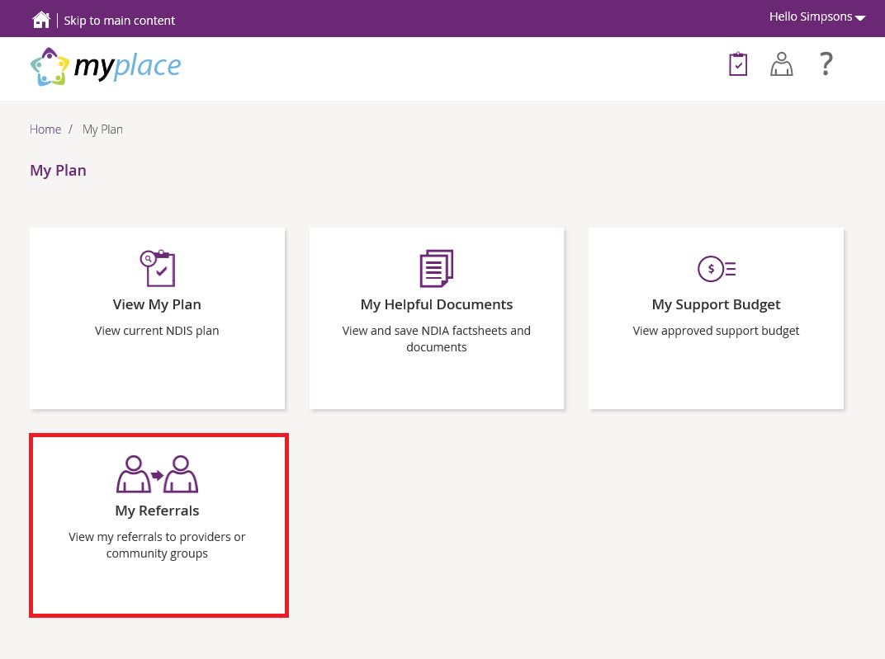
Any current referrals are displayed.
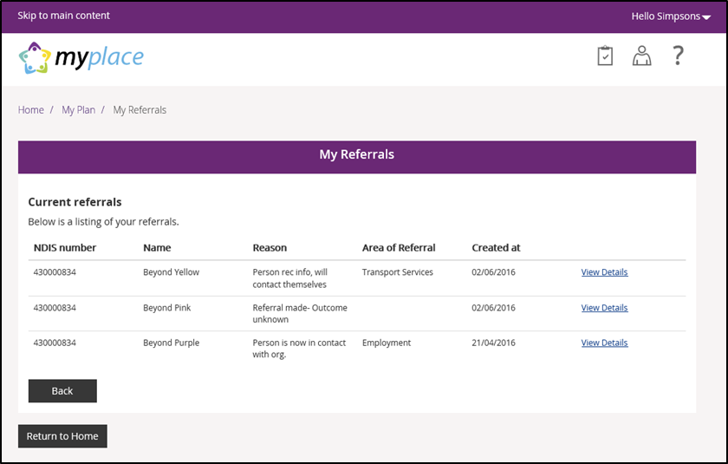
- Select View Details link to find more about the referral.

My Service Bookings
A Service Agreement is an agreement between a Participant and a Provider. It sets out the expectations for which service types will be delivered, and these agreements do not appear in the myplace portal.
As a Participant you are able to choose who provides your supports and how they are provided. In the new Portal, Service Bookings allow you link funded supports in your plan to your choice of Provider.
Service Bookings are the individual requests for a product or service and are required to process payments in the myplace portal. Service Bookings are like a request for a service.
The Service Booking will show the type of support to be provided, the length of time the support is needed for, and confirms there is funding available in your NDIS Plan to pay for these supports. A Participant or Provider is only able to request payment for supports outlined in a Service Booking.
Service Bookings are generally created by Participants, their nominee, or their Plan Manager. A Participant may be supported by an Agency representative to complete their Service Bookings and can also ask a Provider to do this on their behalf.

Create a New Service Booking
- Select My Service Booking tile on the homepage.
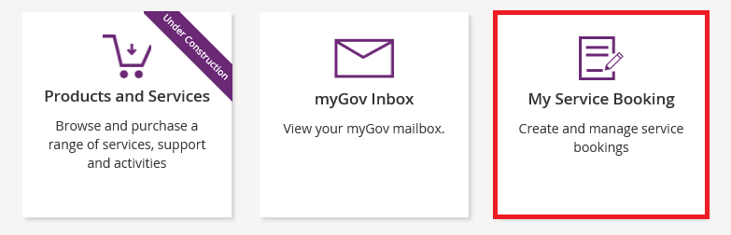
- Select Add My Service Booking tile on the Service Bookings page.
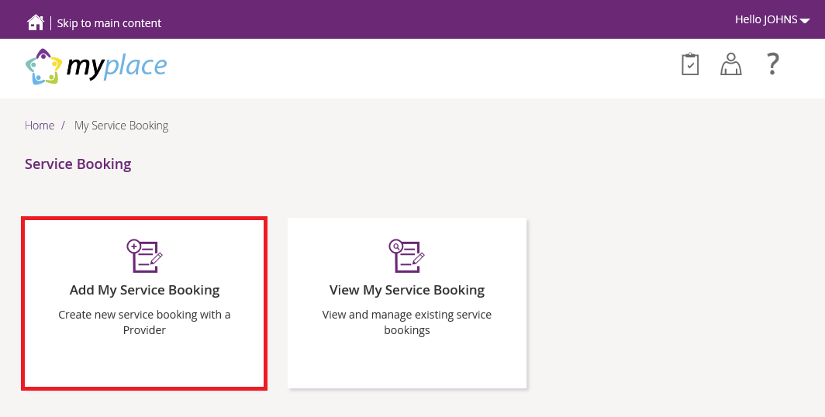
- Select Find a Provider.
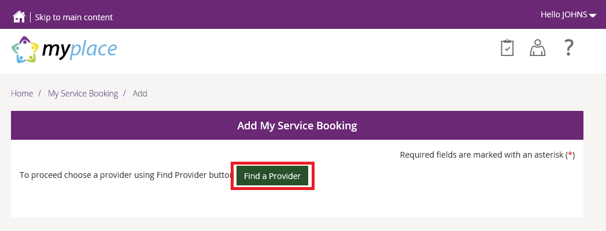
This opens the Provider Finder screen. You can also get here from the Provider Finder tile on the home page.
- If you are looking for Providers in your local area, and your browser is set up to recognise your current location, you can click the Go to my Current Location () icon highlighted below and the system will search for Providers near you. Otherwise you can search for Providers in your local area by typing your Post Code in the Search field.
- You can also search by Provider Name using the Search field. Use the + or – buttons () to ensure the map on screen includes the area in which the Provider is based.
- Select the desired Provider in the Search Results.
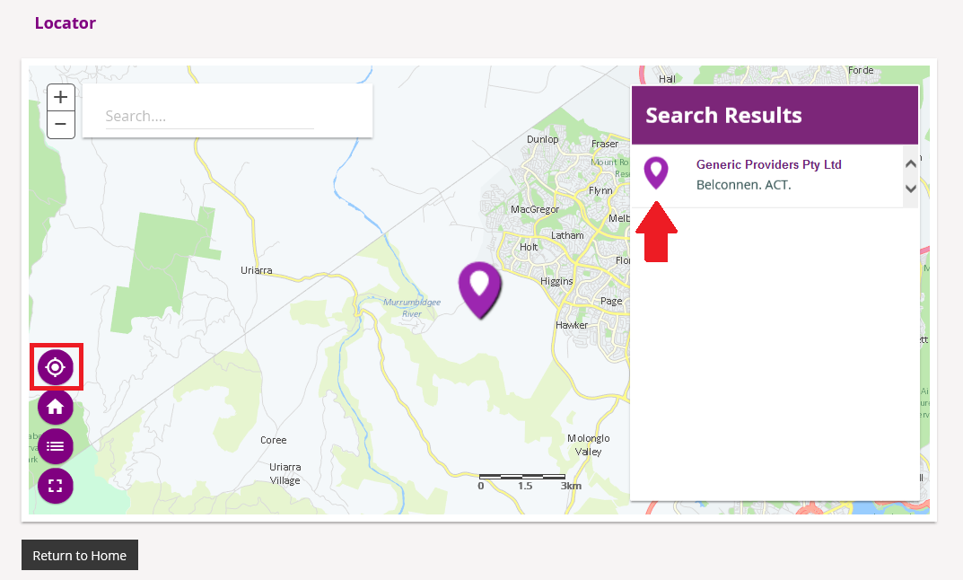
This displays details of the selected Provider.

- To make a booking with this Provider, select Create a Service Booking.
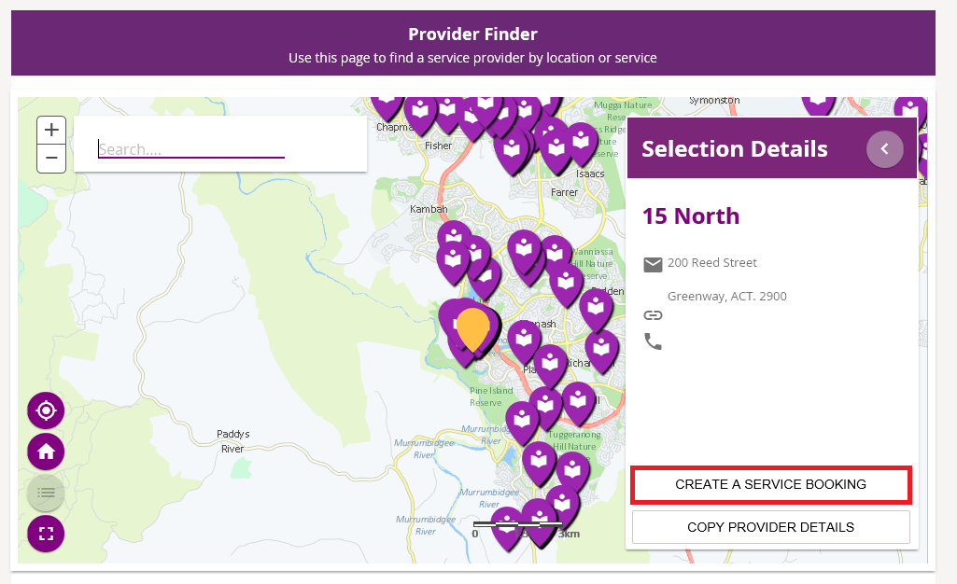
This returns you to the Service Booking Details screen.
- Check that you have the correct Provider selected. If you need to select a different Provider, select Find a Provider to go back to the Provider Finder.
- Select the Service Booking Type from the drop down menu. Most Service Bookings will be a Standard Booking. Plan Management bookings will only be available if you have a Plan Management Provider.
- Type in the Start Date and End Date, or select them using the calendar.
Please Note: these dates must be within the start and end dates of the current plan.
- Select Find Plan.
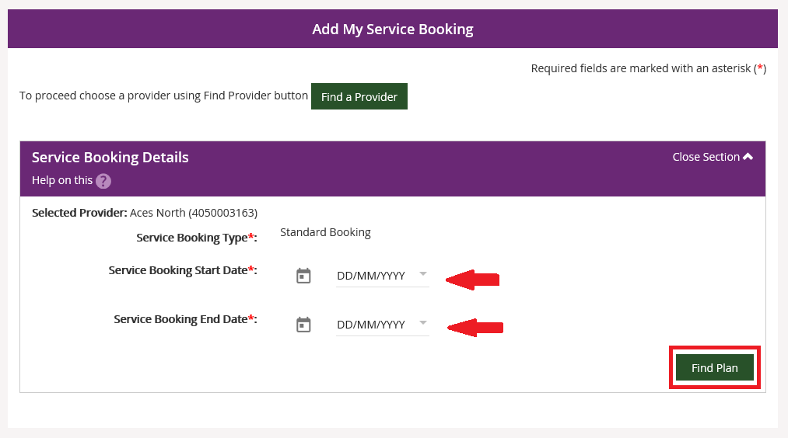
- Select the radio button next to the relevant plan in Step 2.
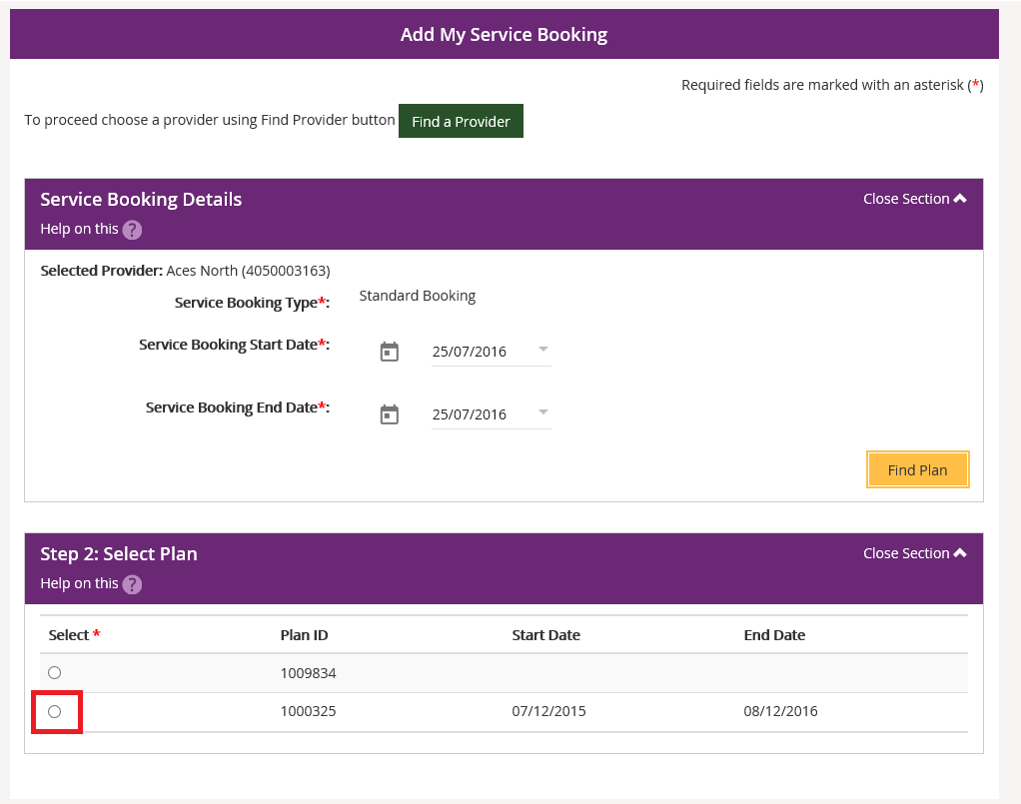

- At Step 3, select the Support Budget and Allocated Amount and then select Add.
- The Support Budget displays the categories of funded support in your NDIS Plan.
- If you want to specify the exact items within the support category, the Item Number allows you to create the booking for a defined item within the support category selected.
- If you want the one Provider to manage all the budget in the support category you do not need to specify the line item.
- Only one booking is required for the entire budget, or the portion you want that Provider to manage.
- If you specify the Item, the Allocated Amount is the agreed rate and you will be asked to enter the Quantity of services needed.
- If you have chosen to only enter the Support Budget or category, you can enter the overall amount you are making the Service Booking for in the Allocated Amount.
- To add more supports, repeat Step 7. Continue until all appropriate support budgets are selected.
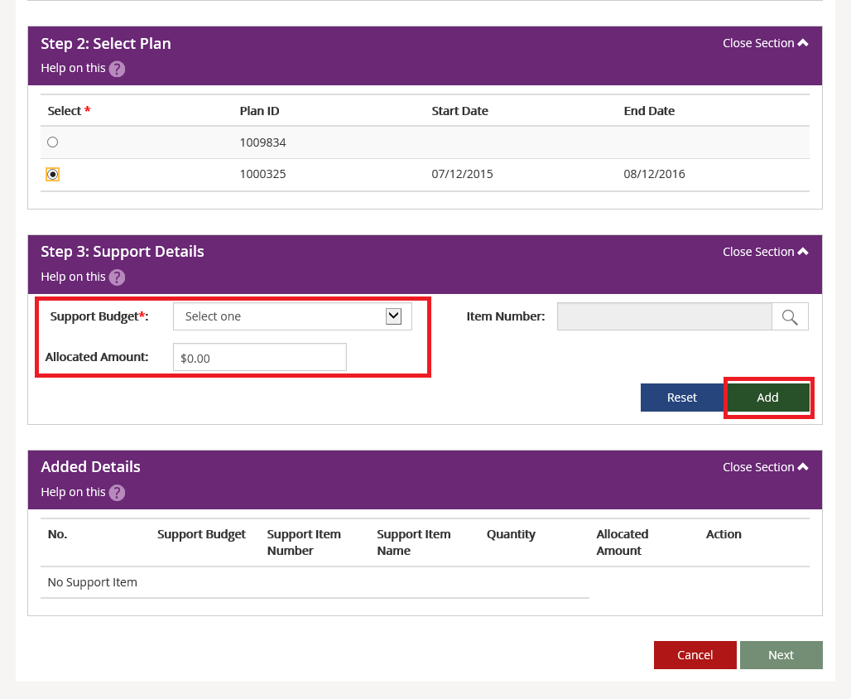

- The booking appears in the Added Details section. If it is correct, select Next. If not, select Edit link to amend it, or the Remove link to delete it and add it again.
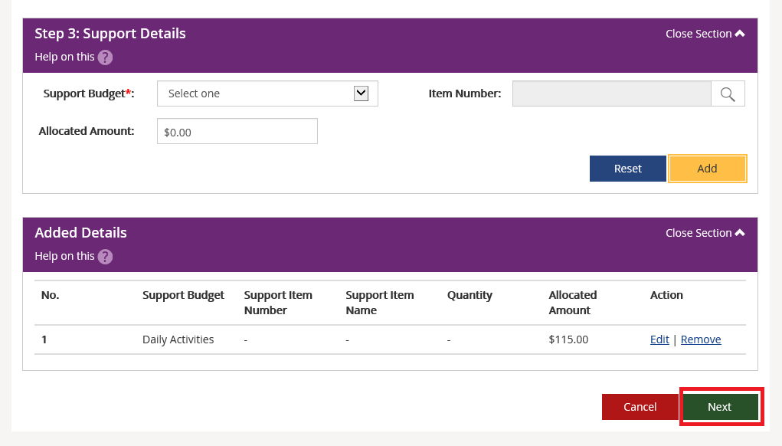
- A summary of supports is displayed. Comments may be added in the comments section.
When everything is correct, select Submit.
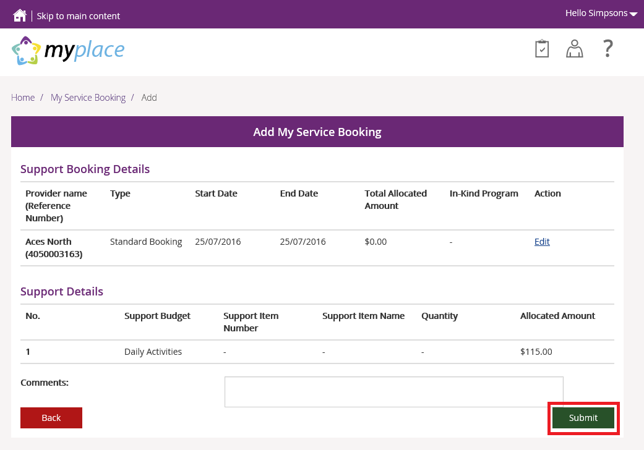
You will receive confirmation of your booking when the Provider approves it. If the Provider rejects the booking, the Service Booking Status will show as Rejected.

View Existing Bookings
- Select View My Service Bookings tile on the Service Bookings page.
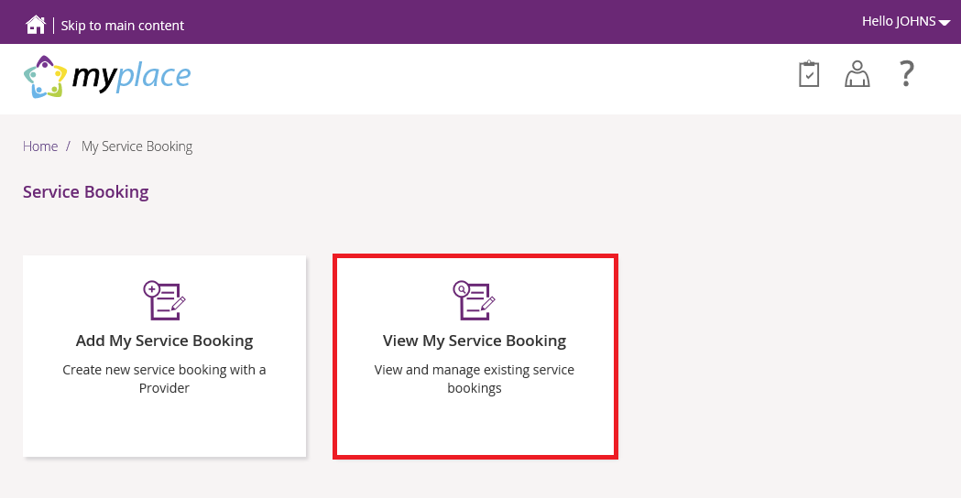
The list of Service Bookings displays.
- To filter this list, select a term from the Search by drop down menu and select Search.
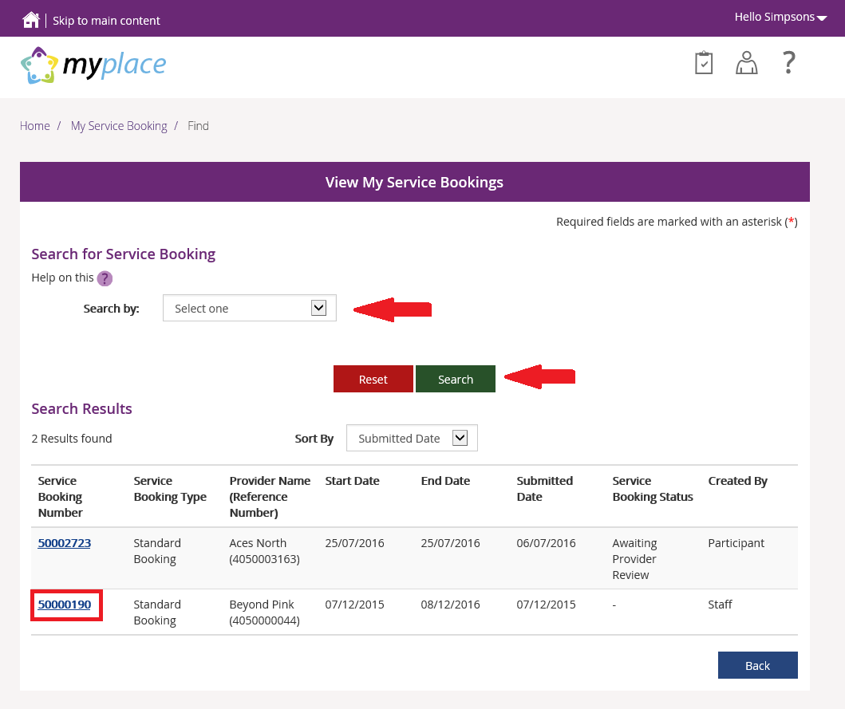
- To view details of any item, select Service Booking Number.

What if I am self-managing funding in my plan?
If you are self-managing supports in your NDIS Plan you will not see a Service Booking for these supports. You will be able to make Payment Requests (previously called a claim) for all categories of support you are self-managing in your Plan.

What if I have a Plan Management Provider?
If you have a Plan Management Provider as part of your NDIS Plan, a Standard Service Booking will be created with the Provider for the plan management supports. Plan Managed Service Bookings will then be created for categories of support which are Plan Managed, to enable the Plan Management Provider to make Payment Requests as required.

How do I change my Service Bookings?
Once a Service Booking has been approved, you can request a change to this Service Booking at any time. When requesting a change to a Service Booking please note:
- A Service Booking can only be extended if the end date of the Service Booking is not already in the past.
- If there is funding remaining in your Plan you can request a change to a Service Booking to reallocate these funds to a different support within your plan.
- Some line items in your plan may be supplied by Providers that are already funded by the State/Territory governments. These supports are identified as In-Kind supports and must be provided by those organisations only.
28 days’ notice is generally required to cancel a Service Booking. Under exceptional circumstances you and your Provider may elect to shorten this time.
When a Service Booking is cancelled, an assessment is made to determine how much funding the existing Provider will need to process outstanding Payment Requests (claims), and what unspent funds can be used to create a new Service Booking.
At the end of a Service Booking, the Provider has up to 60 days to process their Payment Requests.

End Service Booking
In View My Service Booking, select the Service Booking to be edited.
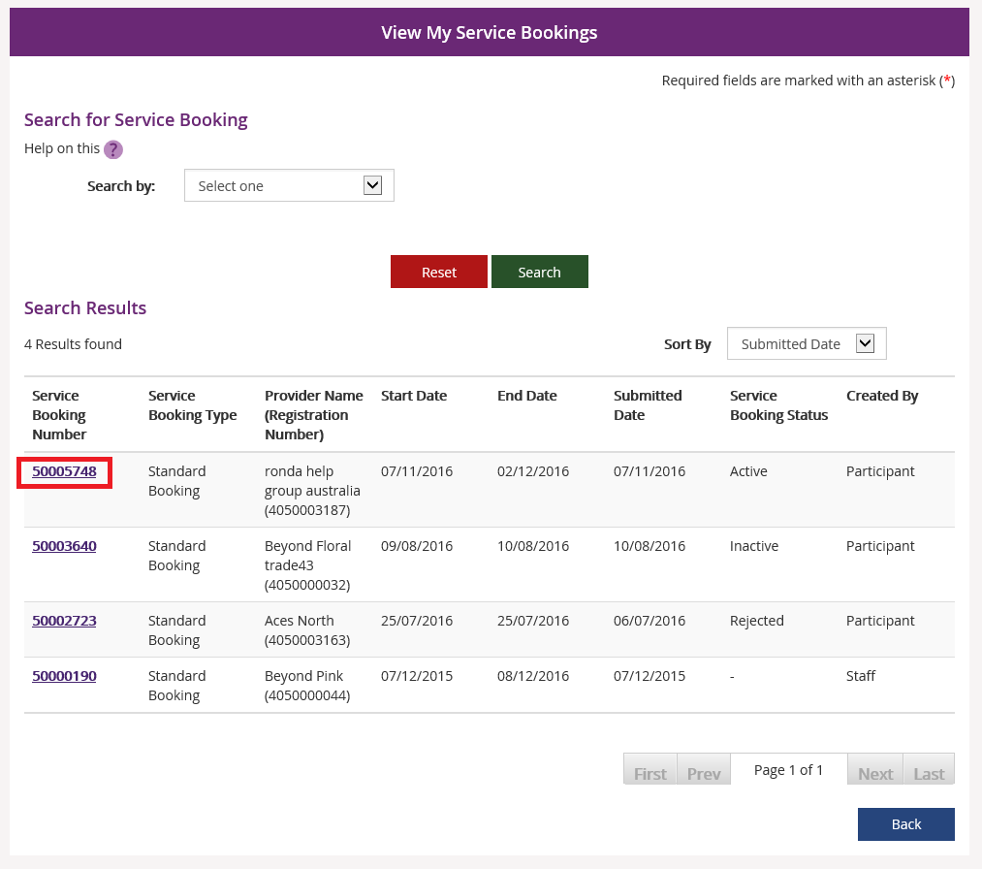
To amend the End Date, or end the Service Booking, select End Service Booking
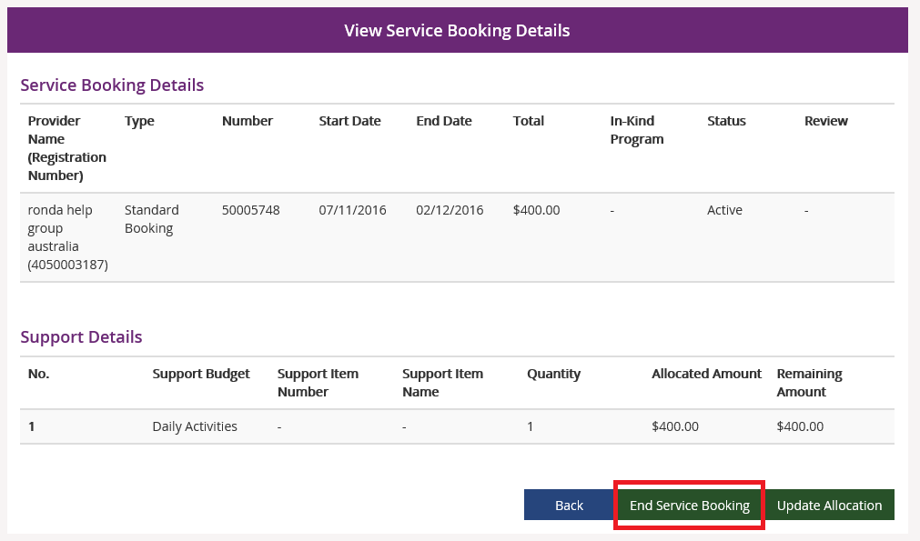

Select the new Service Booking End Date
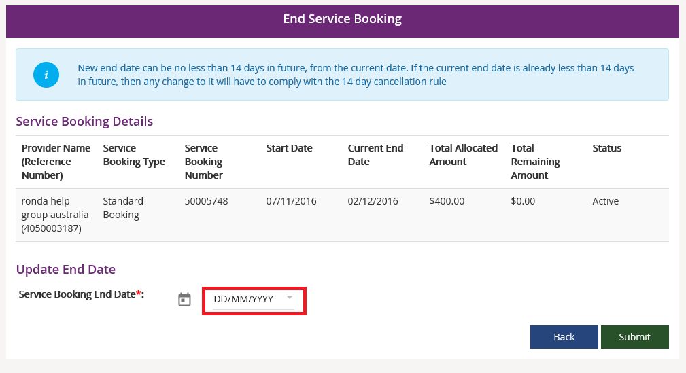
Select the Reason for Ending, and select Submit.
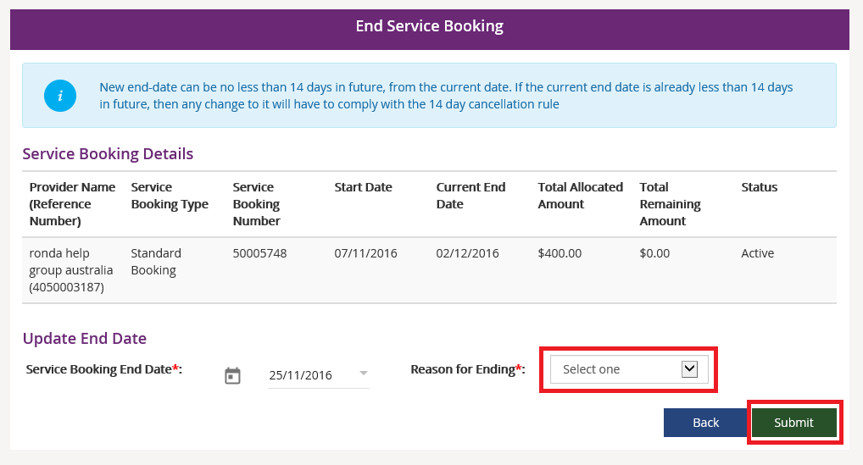

Update Allocation
In View My Service Booking, select the Service Booking you wish to open.
Select the Update Allocation button.
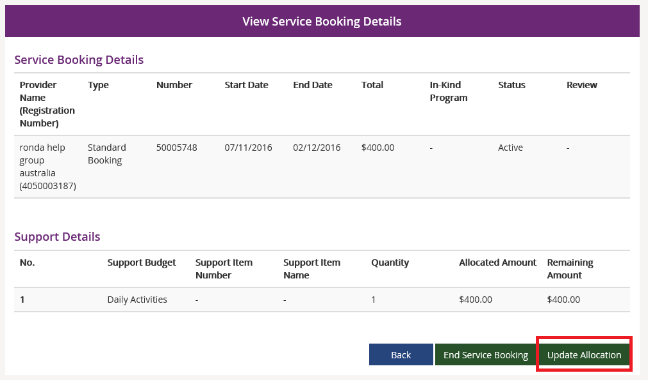
Type in the new Quantity and Unit Price, and then select Submit.
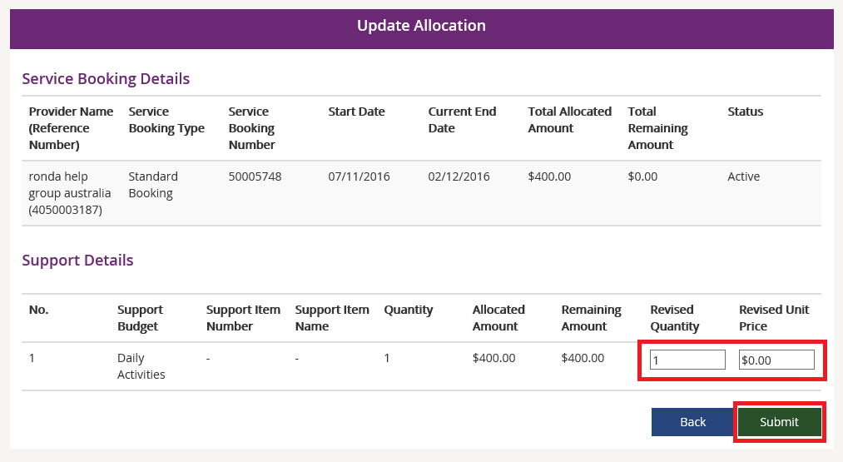

My Payment Request (previously called Claims)
If you are Self Managing funded supports in your NDIS Plan and you have an active bank account recorded, to receive payment you will need to create Payment Requests (previously called claims).
- Select My Payment Request on the myplace homepage.
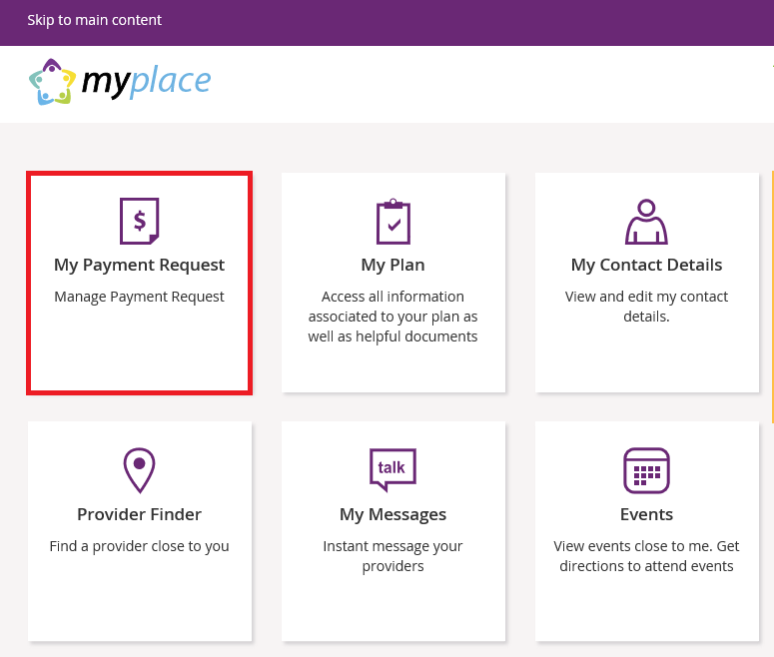

Create a Payment Request (Claim)
- Select Add My Payment Request.
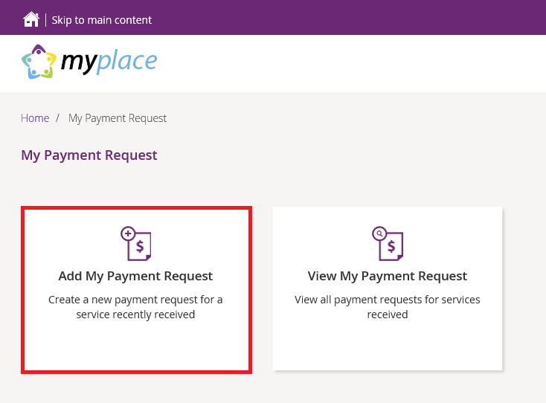
The Add Payment Request screen displays.
- Type in the details of your Payment Request. For more than one Payment Request, select Add Another. Once you are complete, select Next.
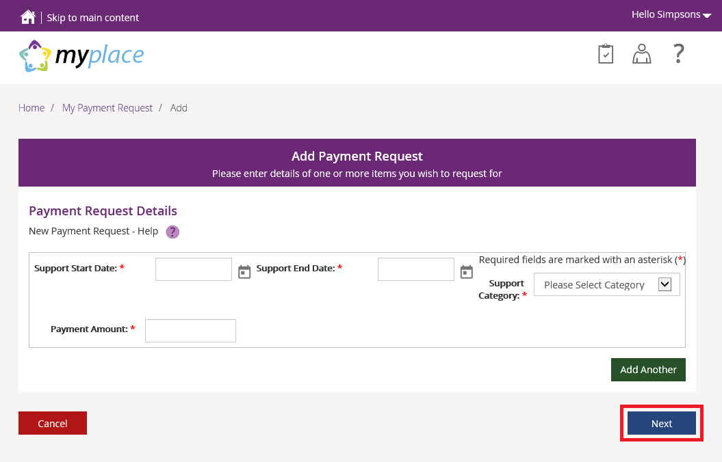
- On the Preview screen, check the details are correct. Tick the declaration box and then select Submit.
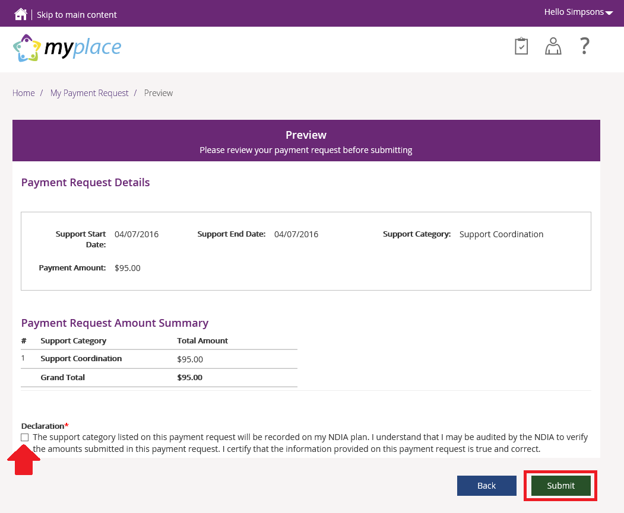
The Confirmation screen displays, showing the details you entered.
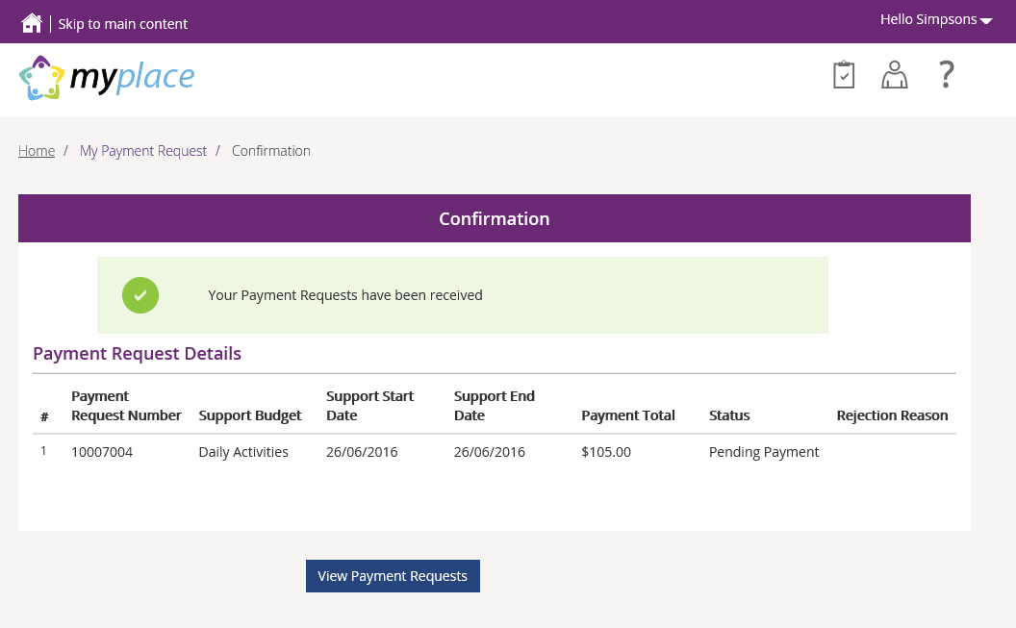
Your Payment Request has been submitted. From here you can either Return to the Home page or go to View Payment Requests.

View Payment Requests (Claims)
You can view the Payment Requests (claims) you have submitted, and also periodic payments. Check here regularly to monitor the progress of your claims.
- Select My Payment Request on the home page.
- Select View My Payment Request on the My Payment Request screen.
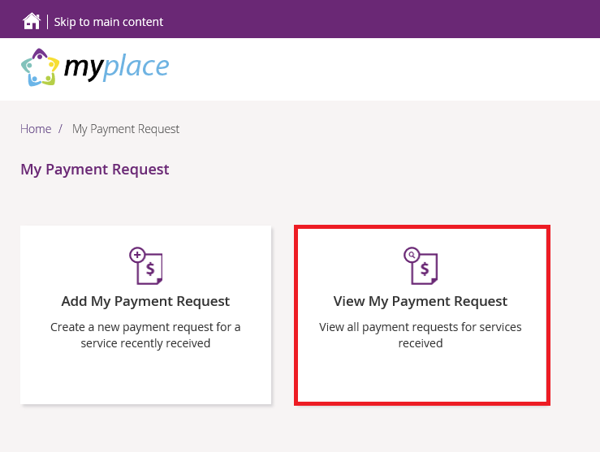

- Choose the Payment Request Type from the drop down menu. The following steps are an example for submitted Payment Requests.
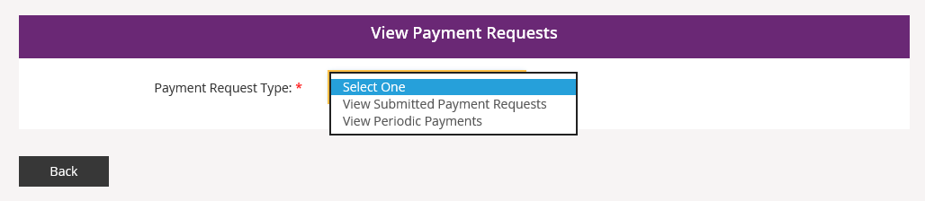
- For View Submitted Payment Requests, the following screen displays.
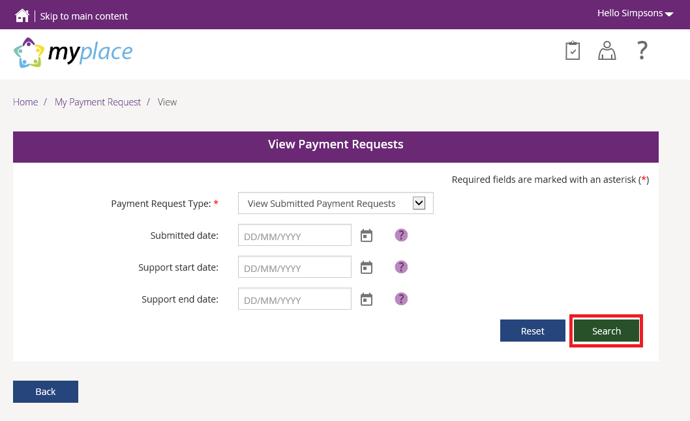
- Select Search for a full list of all requests, or type in the relevant dates to view payments only within the selected time period. A list of your requests displays.
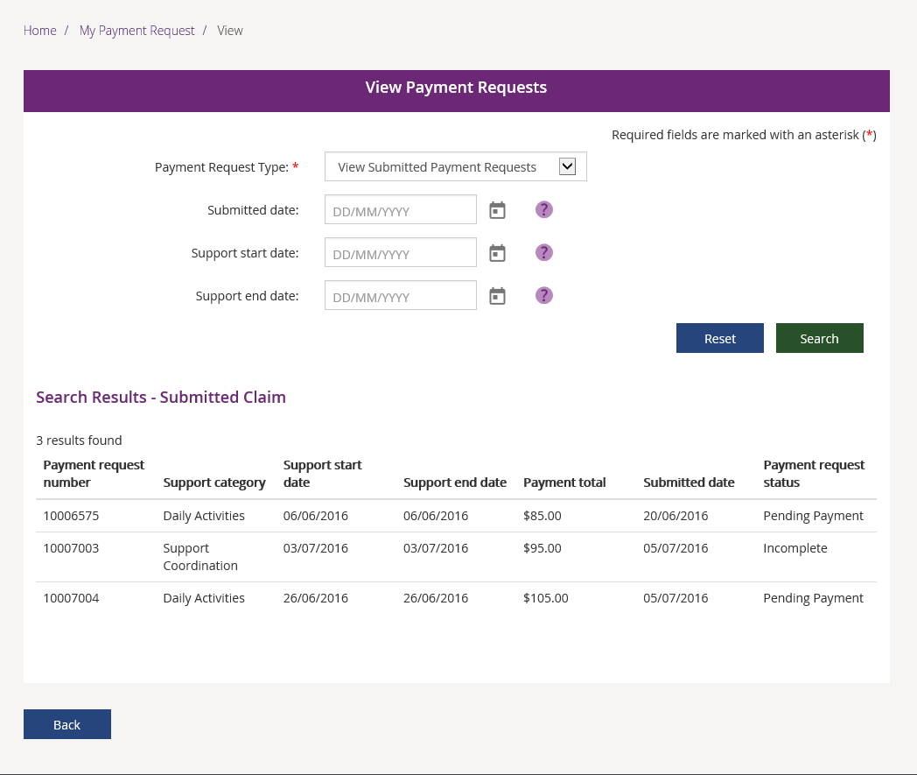

Cancel Payment Requests
You can cancel Payment Requests if they have the status of Pending or Paid.
- Select View My Payment Request on the My Payment Request screen.
- Search for the payment to be cancelled.

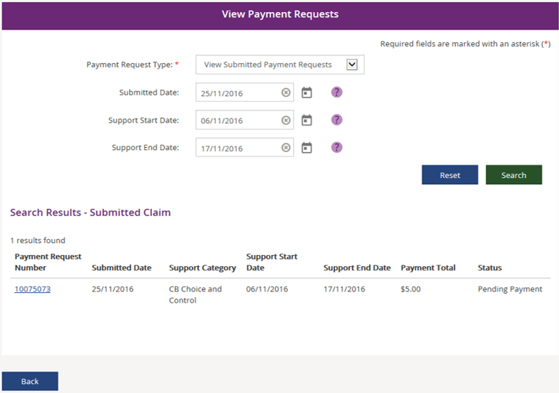
- Select the Payment Request Number.

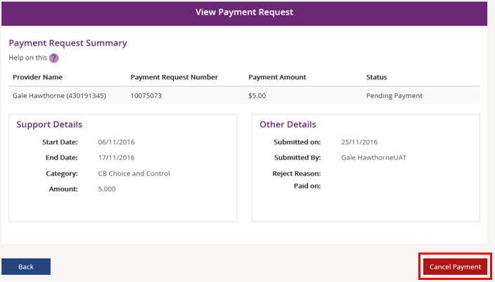
The View Payment Request page displays.
- Select Cancel Payment.

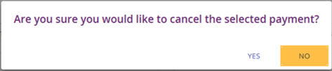
- A option message displays. Select YES to cancel the Payment Request.

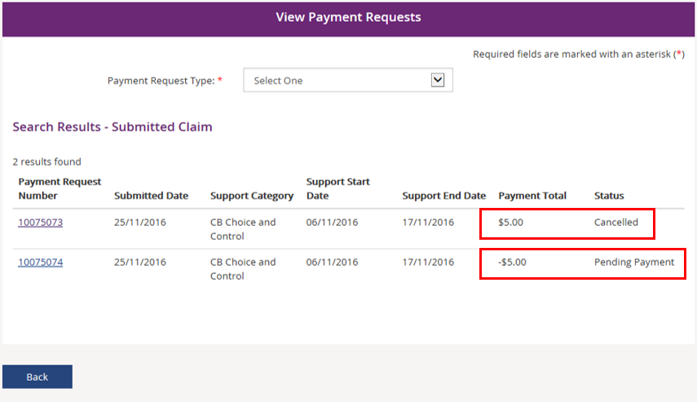
Once you have confirmed the option to cancel, the View Payment Requests screen appears. The Payment Request has been cancelled. A new Payment Request has been created with a negative value of the cancelled payment. This is called an offset payment.
The Service Booking that the Payment Request is attached to will be credited back the amount that was cancelled.

My Appointments
      - Select My Appointments on the myplace home page.
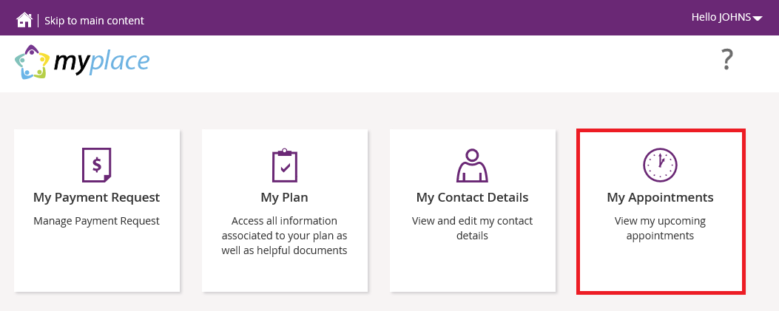
Any appointments linked to your NDIS support are displayed.
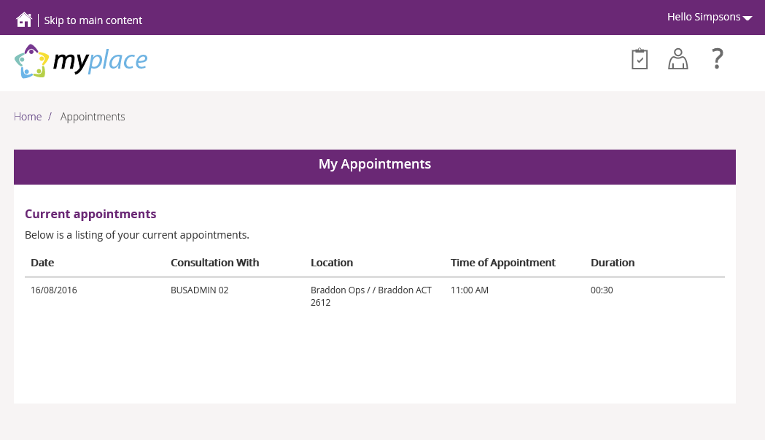

My Messages
You can send instant messages to your Providers.
- Select My Messages tile on the myplace home page.
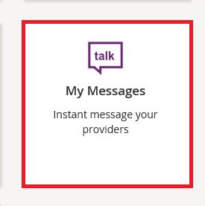
The Messages page opens.
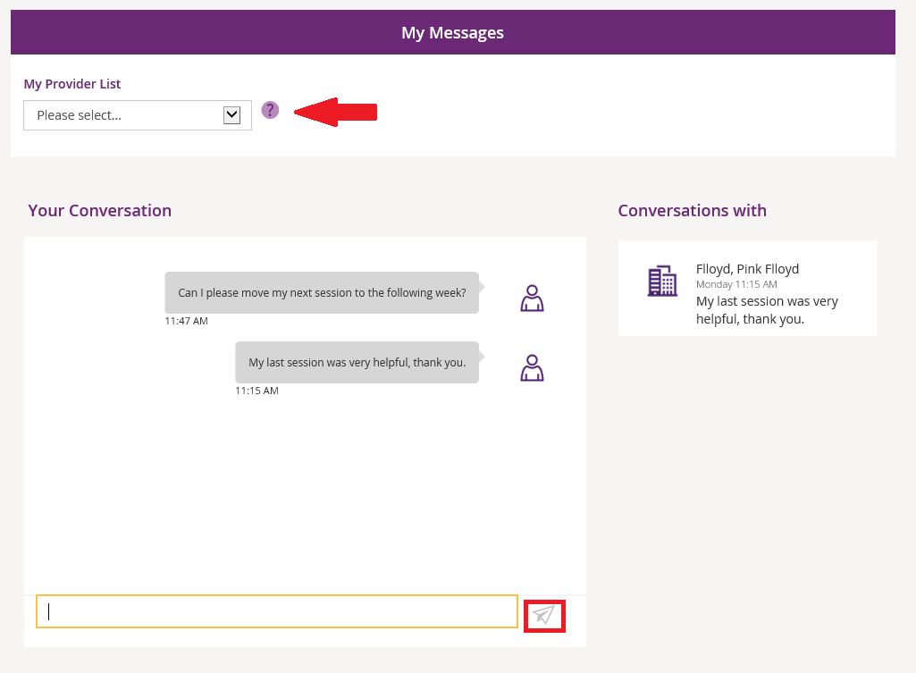
- Select the Provider from the drop down under My Provider List.
- Type your message in the yellow box and select the paper plane to send.
- Current conversations (messages) will appear under Conversations with. You can continue this conversation by clicking on the Providers’ name.
Please note: only Providers with whom you are linked (i.e. through a Service Booking) are available for messaging.

Events
You can search for and view details of forthcoming events that are to be held near you.
- Select the Events tile on the myplace home page.
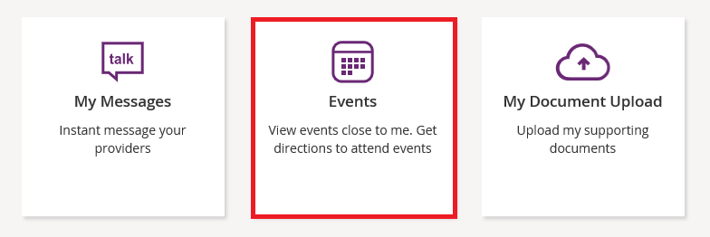
- Select the Events on drop down to select the date range.
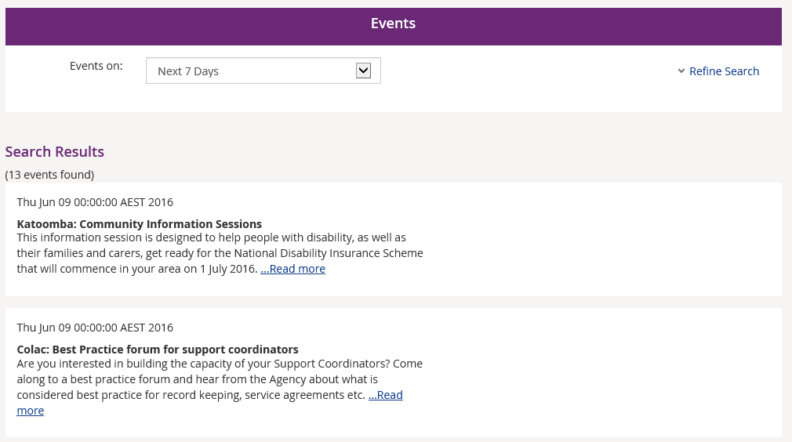
- Select Refine Search to display more search fields.
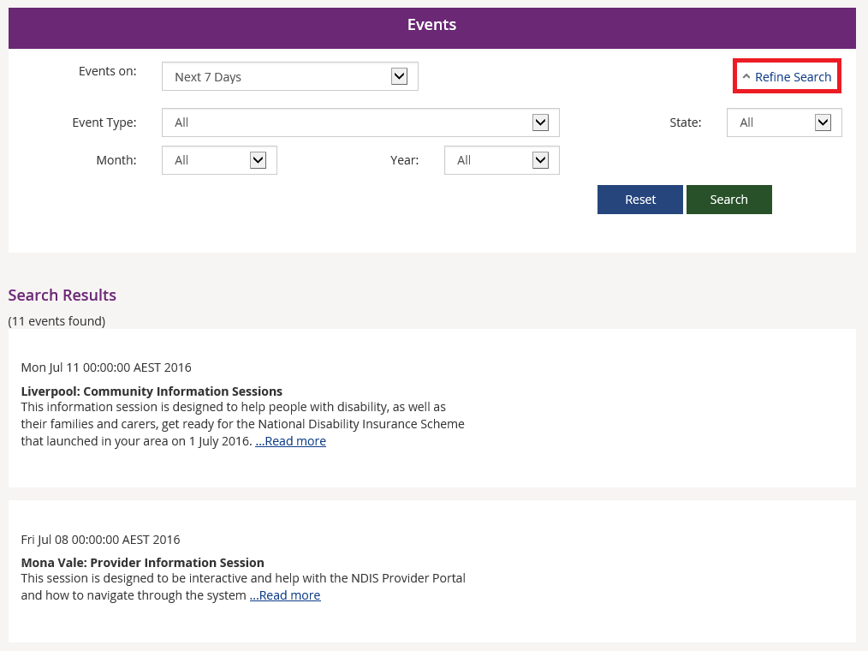

Document Upload
This is where you can send copies of documents to the NDIS.
- Select the My Document Upload tile on the myplace home page.
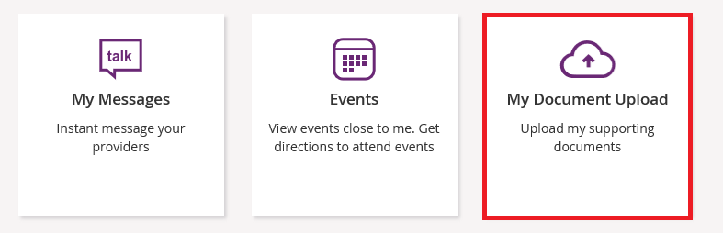
The Document Upload page displays.
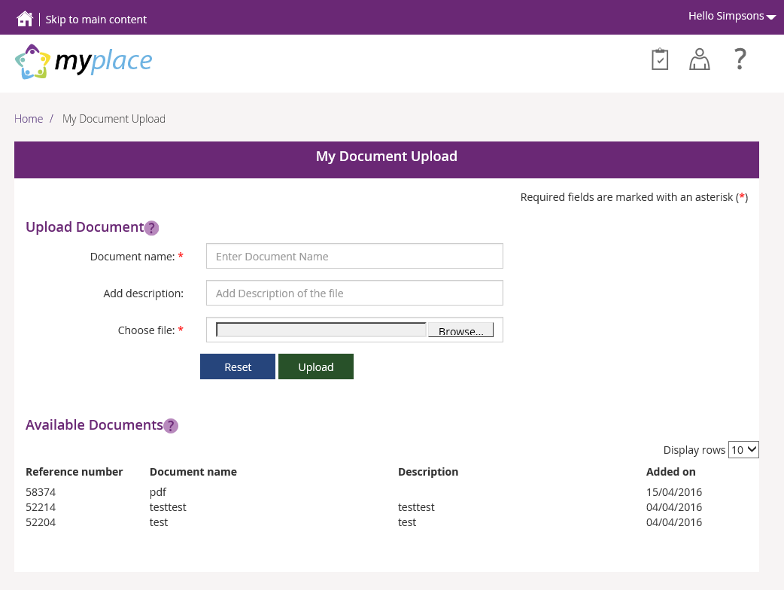
- At Document name, type the name of the document.
- Type a description of the file in the Add description field.
- Select Browse to find the file on your computer.
- Select Upload to send the document to the NDIS.

Products and Services
The Products and Services capability is currently being finalised and will be available at a later date.
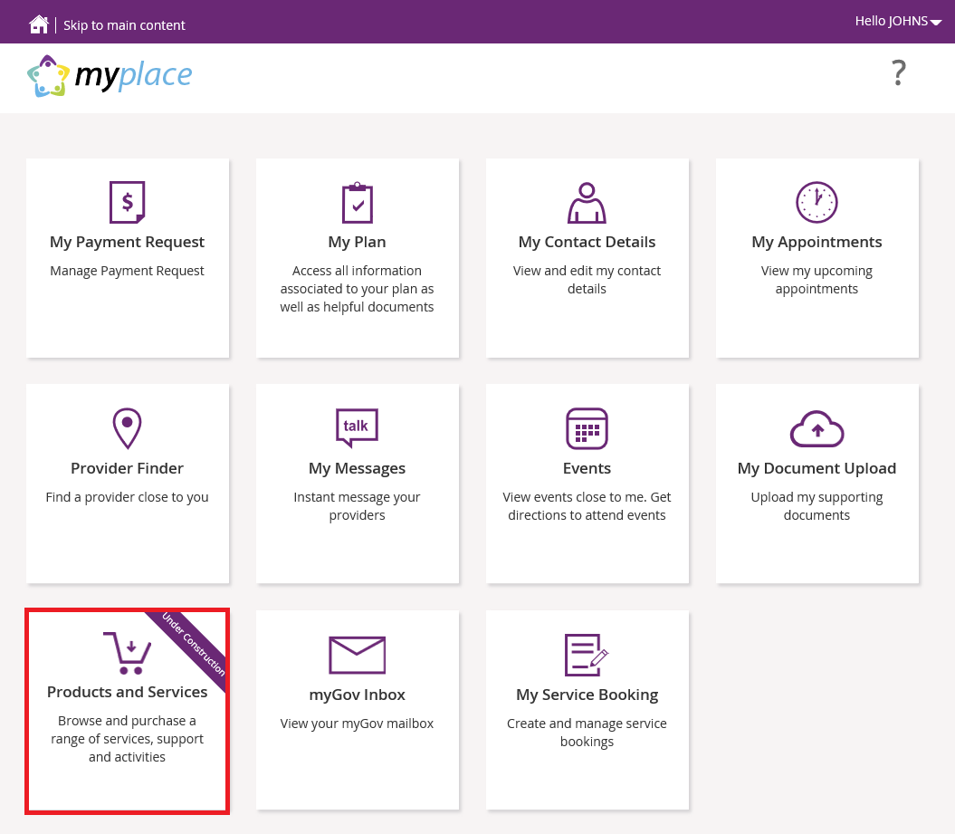

As a Participant you will be able to browse through a range of products and services created to suit your individual needs. You will be able to browse products and services, like ‘Housing’, ‘Behaviour Support’, ‘Help at Home’ etc.
You will also be able to read reviews posted by other Participants, post a review yourself, compare items or create a wish list of products you would like to purchase. You will also be able to view Provider profile details and give feedback directly to the Provider.

myGov Inbox
You can view all email messages from the NDIS here.
Please note: You will only see emails here if you have requested email as your preferred method of receiving information from the NDIS. To update your preferred correspondence method, please go to My Contacts (see page 10 of this guide).
Select the myGov Inbox tile.
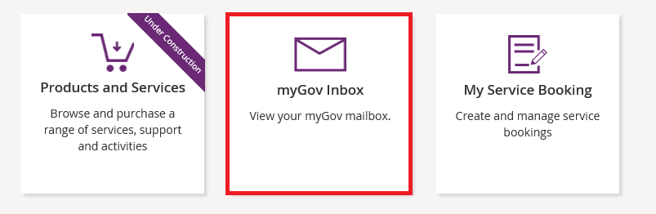
Your inbox opens and displays your incoming messages.
